**SPRINT-4**

|  |  |
| --- | --- |
| TEAM ID | PNT2022TMID23566 |
| Project Name | IoT Based smart crop Protection system for agriculture |

MIT APP inventor to design the APP

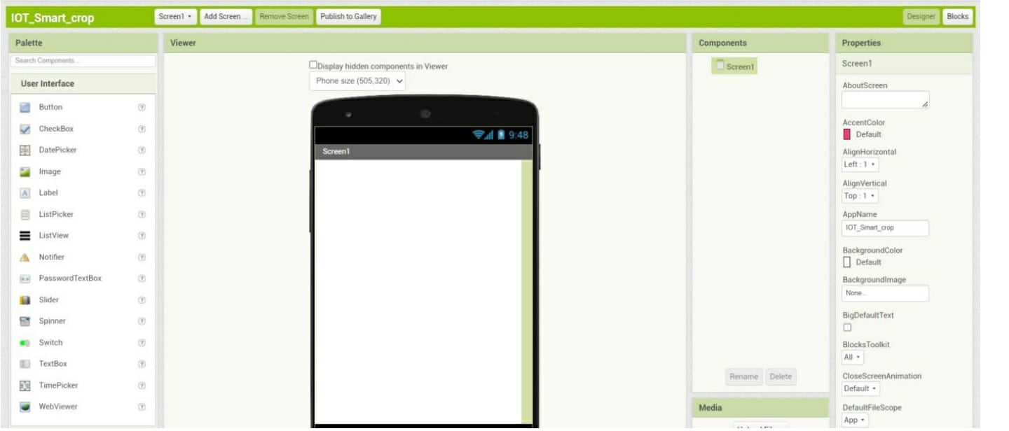

Can be used to display the values

